32.35: From Eq. (32.12):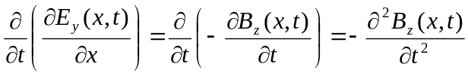
But also from Eq. (32.14): 